**InterFatecs 2022**

**Santana de Parnaíba**

**Problema 6**

XPTO is the software company responsible for a software that processes vehicle plates captured by traffic surveillance cameras. Its developers are currently working on a software update required due to the adoption of the new Mercosur license plates, which are replacing the traditional ones – composed of 3 letters followed by 4 numerical digits. Figure 1 shows a license plate in the new format, in which we have 3 letters followed by a numeric digit, another letter, and finally two numeric digits. Figure 2 illustrates the license plate model that are being replaced, where the hyphen that separates the letter from the numeric digits is just a visual element of the layout – it is not part of the plate itself.

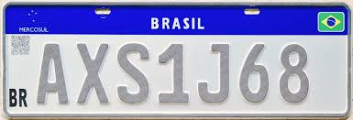

Figure 1 – The new license plate model for Mercosur countries.

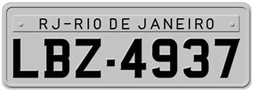

Figure 2 – Old Brazilian license plate model.

When starting the project, XPTO needs something very basic: given a list of license plates provided by the application that decodes the images captured by the cameras, (i) identify which are the new plates, (ii) which are the plates in the old format, and (iii) the invalid readings that may have occurred. Due to the characteristics of the software that decodes the images, all readings bring only the characters ASCII codes. For instance, the plate in Figure 1 would appear as 65 66 67 49 67 51 52 and the plate in Figure 2 would appear as 88 88 88 48 48 48 48 (without the hyphen).

Your task is to determine, for a given license plate, whether it is a new model, an old model, or an invalid read. Assume that the valid letters will be capital letters only (codes 65 to 90 in the ASCII table). Additionally, remember that the numeric digits correspond to ASCII characters with code 48 to 57.

**Input**

The input is composed of many lines with 7 integers separated by a white space each, representing each license plate character as captured by the cameras. Each integer is in the interval [1, 200].

**Output**

Print “MERCOSUL” for the new Mercosur plates, “ANTIGA” for the old model plates, and “ERRO” for the inputs that do not fit any of these license plate models.

**Exemplo de Entrada 1 Exemplo de Saída 1**

|  |  |
| --- | --- |
| 65 66 67 49 67 51 52  88 88 88 48 48 48 48  23 45 72 23 89 42 43 | MERCOSUL  ANTIGA  ERRO |